2nd June 2026

DB_connection:
package crud_operations;
import java.sql.Connection;
import java.sql.DriverManager;
public class DB_Connection {
public static void main(String[] args) {
DB_Connection obj_DB_Connection=new DB_Connection();
System.out.println(obj_DB_Connection.get_connection());
}
public Connection get_connection(){
Connection connection=null;
try {
Class.forName("com.mysql.jdbc.Driver");
connection = DriverManager.getConnection("jdbc:mysql://localhost:3306/test","root", "root");
} catch (Exception e) {
System.out.println(e);
}
return connection;
}
}
CRUD_OPERATIONS
package crud_operations;

import java.sql.Connection;
import java.sql.PreparedStatement;
import java.sql.ResultSet;

public class CRUD_Test {

public static void main(String[] args) {

CRUD_Test objTest = new CRUD_Test();

// CREATE
objTest.create_data("1", "Gill", "gill@gmail.com");
objTest.create_data("2", "Pradeep", "pradeep@gmail.com");

// READ
objTest.read_data();

// ALTER TABLE
objTest.alter_table();

// TRUNCATE TABLE
// objTest.truncate_data();
}

// CREATE
public void create_data(String sl_no, String name, String email) {

DB_Connection obj_DB_Connection = new DB_Connection();
Connection connection = obj_DB_Connection.get_connection();

try {

String query = "INSERT INTO crud(sl_no,name,email) VALUES(?,?,?)";

PreparedStatement ps = connection.prepareStatement(query);

ps.setString(1, sl_no);
ps.setString(2, name);
ps.setString(3, email);

System.out.println(ps);

ps.executeUpdate();

System.out.println("Data Inserted Successfully");

} catch (Exception e) {
System.out.println(e);
}
}

// READ
public void read_data() {

DB_Connection obj_DB_Connection = new DB_Connection();
Connection connection = obj_DB_Connection.get_connection();

try {

String query = "SELECT * FROM crud";

PreparedStatement ps = connection.prepareStatement(query);

ResultSet rs = ps.executeQuery();

while (rs.next()) {

System.out.println("Sl No : " + rs.getString("sl_no"));
System.out.println("Name : " + rs.getString("name"));
System.out.println("Email : " + rs.getString("email"));
System.out.println("---------------------");
}

} catch (Exception e) {
System.out.println(e);
}
}
//UPDATE
objTest.update_data("2", "22", "jawad2", "jawad2@gmail");
//DELETE
objTest.delete_data("1");

// ALTER
public void alter_table() {

DB_Connection obj_DB_Connection = new DB_Connection();
Connection connection = obj_DB_Connection.get_connection();

try {

String query = "ALTER TABLE crud ADD mobile VARCHAR(15)";

PreparedStatement ps = connection.prepareStatement(query);

ps.executeUpdate();

System.out.println("Table Altered Successfully");

} catch (Exception e) {
System.out.println(e);
}
}

// TRUNCATE
public void truncate_data() {

DB_Connection obj_DB_Connection = new DB_Connection();
Connection connection = obj_DB_Connection.get_connection();

try {

String query = "TRUNCATE TABLE crud";

PreparedStatement ps = connection.prepareStatement(query);

ps.executeUpdate();

System.out.println("Table Truncated Successfully");

} catch (Exception e) {
System.out.println(e);
}
}
}

Output:

//Create

//Read
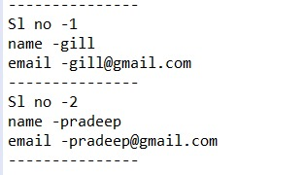

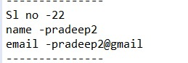

//update
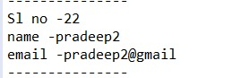

//Delete
Output:

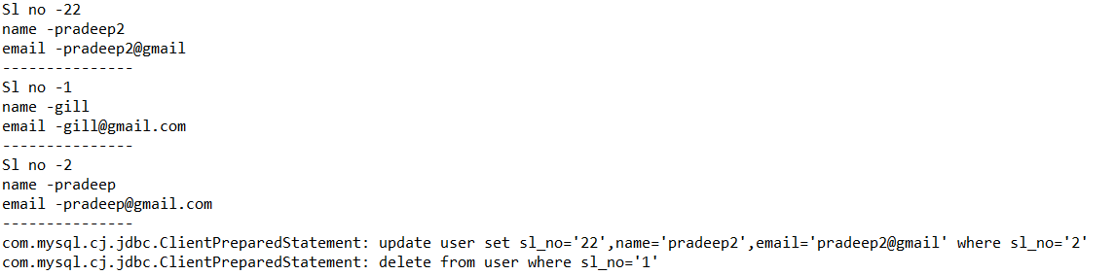

//CRUD 2
import com.mongodb.client.MongoClient;
import com.mongodb.client.MongoClients;
import com.mongodb.client.MongoDatabase;

public class MongoDBConnection {
public static void main(String[] args) {
String connectionString = "mongodb://localhost:27017";

try (MongoClient mongoClient = MongoClients.create(connectionString)) {
MongoDatabase database = mongoClient.getDatabase("testdb");
System.out.println("Connected successfully to MongoDB!");
}
}
}
MONGO CONNECTIONS
package crud_operations;
import com.mongodb.client.MongoClient;
import com.mongodb.client.MongoClients;
import com.mongodb.client.MongoDatabase;

public class MongoDBConnection {
public static void main(String[] args) {
String connectionString = "mongodb://localhost:27017";

try (MongoClient mongoClient = MongoClients.create(connectionString)) {
MongoDatabase database = mongoClient.getDatabase("vit");
System.out.println("Connected successfully to MongoDB!");
}
}
}
Output:

